**PROJECT-I REPORT**

**On**

**Human Resource Management System**

Submitted to Rajasthan Technical University

in partial fulfillment of the requirement for the award of the degree of

**B.TECH.**

**in**

**COMPUTER ENGINEERING**

**Submitted By**

**Akshat Jain (Piet15ce011)**

**Megha Soni (Piet15ce061)**

**Mukesh Kumar Suthar (Piet15ce065)**

**Under the Guidance of**

**Mr. Praveen Gupta**

at



**POORNIMA INSTITUTE OF ENGINEERING & TECHNOLOGY, JAIPUR**

**Rajasthan Technical University, KOTA**

**October, 2018**

**CERTIFICATE**

This is to be certified that the project entitled “ HRMS” has been submitted for the Bachelor of Computer Science and Engineering, Poornima Institute Of Engineering & Technology, Jaipur during the academic year 2018-2019 is a bonafide piece of project work carried out by “ **Akshat Jain, Megha Soni & Mukesh Kumar Suthar**” towards the partial fulfillment for the award of the Degree (B.Tech.) under the guidance of “**Mr. Praveen Gupta**” and supervision and no part of there of has been submitted by them for any degree or diploma.

Project Guide Project Coordinator Mr. Deepak Moud

Mr. Praveen Gupta Prof. (Dr.) Praveen Gupta (H.O.DCSE)

(Assistant Professor) (Professor)

**CANDIDATE’S DECLARATION**

We, **Akshat Jain (Piet15ce) Megha Soni (Piet15ce061) & Mukesh Kumar Suthar (Piet15ce)** B.Tech (Semester- VIII) of “**Poornima Institute Of Engineering & Technology, Jaipur”** hereby declare that the Project Report entitled **“HRMS”** is an original work and data provided in the study is authentic to the best of our knowledge.This report has not been submitted to any other Institute for the award of any other degree.

**Akshat Jain Megha Soni Mukesh kumar suthar**

|  |  |  |
| --- | --- | --- |
| **(PIET15CE011)** | **(Piet15ce061)** | **(PIET15CE065)** |

|  |  |
| --- | --- |
| **Place: Jaipur** |  |
| **Date:23/10/2018** |  |

**ACKNOWLEDGEMENT**

It is our pleasure to be indebted to various people, who directly or indirectly contributed in the development of this work and who influenced our thinking, behavior and acts during the course of study.

We express our sincere gratitude to ***Dr. O. P. Sharma,*** Director, PIET for providing us an opportunity to undergo this Major Project as the part of the curriculum.

We are thankful to ***Mr. Deepak Moud, HOD, CS*** for his support, cooperation, and motivation provided to us during the training for constant inspiration, presence and blessings.

We also extend our sincere appreciation to***Prof. (Dr.) Praveen Gupta*** who provided his valuable suggestions and precious time in accomplishing our Project report.

Lastly, we would like to thank the almighty and our parents for their moral support and friends with whom we shared our day-to-day experience and received lots of suggestions that improved our quality of work.

|  |  |  |
| --- | --- | --- |
| **Akshat Jain** | **Megha Soni** | **Mukesh Kumar Suthar** |
| **(Piet15ce011)** | **(Piet15ce061)** | **(Piet15ce065)** |

**TABLE OF CONTENTS**

|  |  |  |
| --- | --- | --- |
| **CHAPTER NO.** | **TOPICS** | **PAGE NO.** |
|  | TITLE PAGE | I |
|  | CERTIFICATE | II |
|  | CANDIDATE’S DECLARATION | III |
|  | ACKNOWLEDGEMENT | IV |
|  | TABLE OF CONTENTS | V |
|  | TABLE OF FIGURE | VI |
|  | ABSTRACT | VII |
| 1 | **INTRODUCTION TO PROJECT** | 1 |
|  |  |  |
|  | Project Aim and Objective  Problem Statement  Background of the Project (Literature Survey)  Software Requirements  Hardware Requirements |  |
| 2 | **PRODUCT BACKLOG** |  |
|  | 1. PRODUCT Backlog 2. Sprint Backlog-1 3. Sprint Backlog-2 |  |
|  |  |  |
| 3 | **TECHNOLOGY APPLIED AND PROJECT MANAGEMENT** |  |
|  | Brief Description of All technology Apply in the Project.  Project management  Agile  Relevance to Society  Ethics  Life Long Learning  Project Finance  Environment and Sustainability |  |
| 4 | **PROJECT IMPLEMENTATION** |  |
|  | Sprint Backlog-1  Sprint Backlog-2 |  |
|  |  |  |
| 5 | **CONCLUSION** |  |
|  | Results  Conclusion  Future Scope |  |
| 6 | ANNEXURES |  |
|  | References |  |
|  |  |  |

**LIST OF FIGURES**

|  |  |  |
| --- | --- | --- |
| **S. NO.** | **FIGURE** | **PAGE NO.** |
| 1. | Fig 4.1 | 37 |
| 2. | Fig 4.2 | 38 |
| 3. | Fig 4.3 | 39 |
| 4. | Fig 4.4 | 40 |

**LIST OF TABLES**

|  |  |  |
| --- | --- | --- |
| **S. NO.** | **FIGURE** | **PAGE NO.** |
| 1. | Fig 1.1 Registration_table | 13 |

**ABSTRACT**

**KEYWORDS:**

* Java
* Xml
* Php
* mysql
* Project Management
* Networking

**CHAPTER 1**

**INTRODUCTION TO PROJECT**

( 10 to 15 page)

**Project Aim and Objective:**

The main objective to build an automated and computerized system which will work in order to give proper detail of any employee to the administration and all required information and notification to the every employee.

It will reduce human effort and will work to maintain the proper management of employee related information like bounce attendance, leave application, fee status etc.

**Problem Statement:**

Every employee has its own data which has to be maintain by the company. This process required human effort to a great extent. To reduce this human effort it is required to develop an automated and computerized system which maintain record of these information.

**Background of the Project(Literature Survey):**

This project is quit effected because it will reduce human effort to a great extent. The company which is demand the project is Arkles Pvt. Lmt., which work with this technology.

Fig 1.1 Registration_table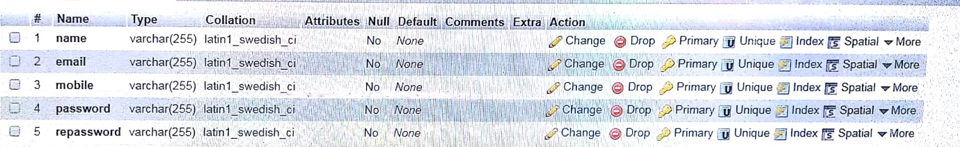

**Software and Hardware Requirements:**

**Server Side Hardware and Software Requirement:**

* Windows Operating System
* Xampp server
* 8 GB RAM
* 1 TB Hard-disk

**Development Side Hardware and Software Requirement:**

* PHP
* Coral Draw X13 (For Creating Project Synopsis, Design & Report)
* Android Studio
* Android Software Development Kit
* Java Development Kit
* 3 GHZ Processor
* Windows Operating System
* 8 GB RAM
* Xampp server
* My SQL.

**Client Side Hardware and Software Requirement:**

* Android Device (Phone, Tablet)
* 5.0 Lollipop (minimum version)
* 1 GB RAM minimum
* Processor Speed 1.3 GHZ minimum
* Internet Connection

**CHAPTER 2**

**PRODUCT BACKLOG**

(20 to 30 page)

1. **PRODUCT Backlog**

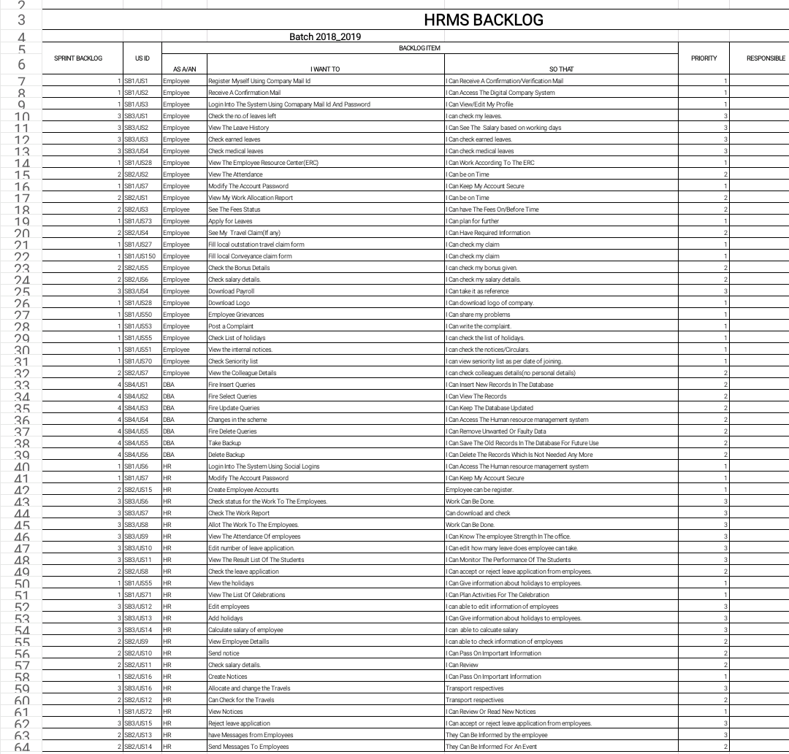

The Product backlog is the basic terminology used to create the main schedule in which the work has to be completed. In this Product backlog we have explained various features and qualities of the project named HRMS (Human Resource Management System), which is created by the help of Android Technology. It include various feature which make is more efficient and more valuable as compare to various manual system work in order of management of various kind of information on employee.

It will reduce human effort and will work to maintain the proper management of employee related information like bounce attendance, leave application, fee status etc.

Every employee has its own data which has to be maintain by the company. This process required human effort to a great extent. To reduce this human effort it is required to develop an automated and computerized system which maintain record of these information.

1. **Sprint Backlog-1**

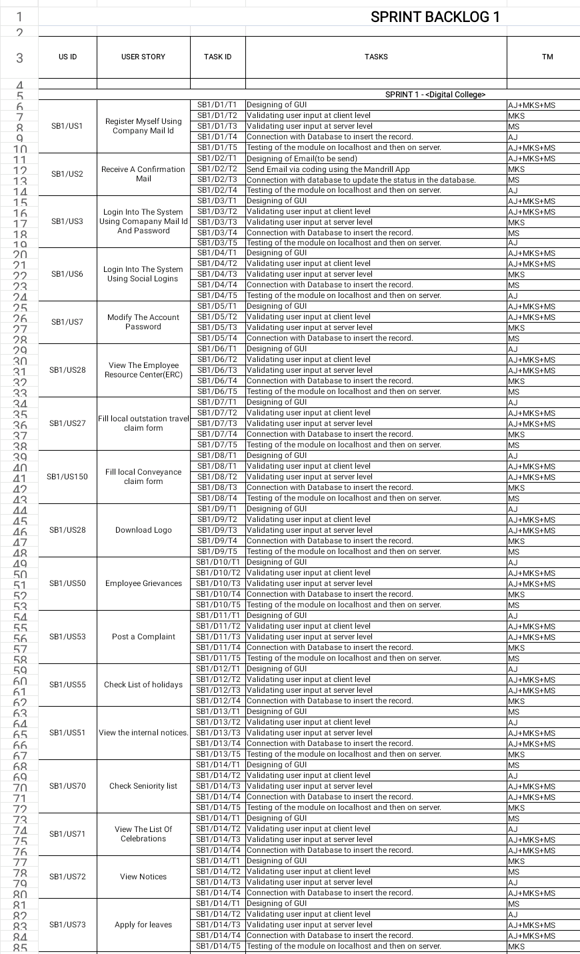As the main product backlog is divided into 4 sprint backlog which has to be completed on time with out any delay. The main agenda of sprint backlog 1 is to create the registration and login panel so that each employee can be identified with the separate identity, by which data related to every employee can be stored separately.

It will reduce human effort and will work to maintain the proper management of employee related information like bounce attendance, leave application, fee status etc.

Every employee has its own data which has to be maintain by the company. This process required human effort to a great extent. To reduce this human effort it is required to develop an automated and computerized system which maintain record of these information.

**Sprint Backlog-2**

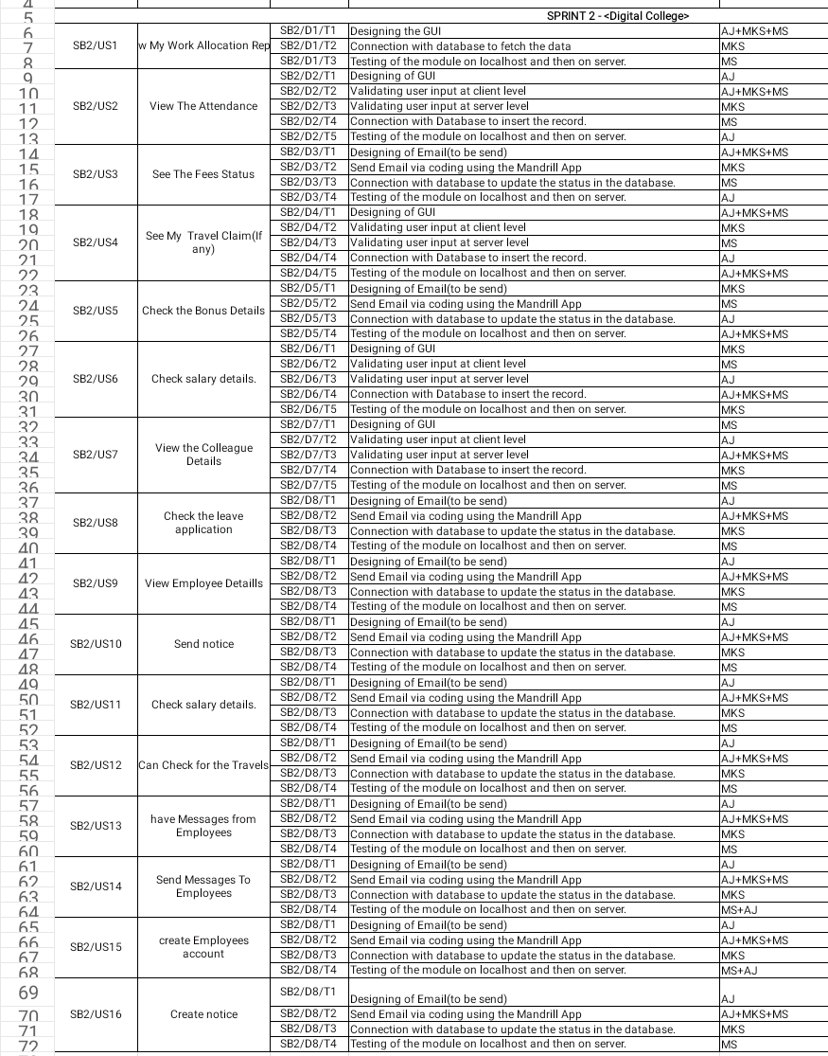

The main agenda of sprint backlog 2 is to create the required information set in each profile created after registration. Various features like to add notice or any application will be performed here, apart from this an employee can have its own information like fee status, bounce information, leaves, transport information etc.

**CHAPTER 3**

**TECHNOLOGY APPLIED AND PROJECT MANAGEMENT**

( 10 to 15 page)

Brief Description of All technologiesAppled in the Project.

The JAVA programming language and MySQL™ database provide a powerful, open, and free platform for developing database-driven Mobile Application for Android Platform.  
MySQL is the open source community's most popular Relational Database.   
This MySQL Developer course is the foundation course for students planning on designing and implementing applications that make use of MySQL. This course covers essential SQL statements for data design, querying, and programming.  
The ANDROID training course aims to teach a set of basic, intermediate and advanced skills for implementing practical, industrial-strength ANDROID-based Mobile applications. Our best ANDROID training course encourages the participant to explore MySQL database fundamentals, as well as MySQL features.  
This hand on **ANDROID Programming course** provides the knowledge necessary to design and develop dynamic, database-driven Mobile application using JAVA and XML. JAVA is a programming language written for the web, quick to learn, easy to deploy and provides substantial functionality required for e-commerce. This course introduces the JAVA framework and syntax, and covers in depth the most important techniques used to build Android application.

**Skills:**

* Java, xml, php, mysql
* Knowing What You Don’t Know
* Business Communication
* Business Finance
* Project Management
* Networking

**Project management :**

Project management is the application of processes, methods, knowledge, skills and experience to achieve the project objectives. General. A project is a unique, transient endeavor, undertaken to achieve planned objectives, which could be defined in terms of outputs, outcomes or benefits.

Project management is the practise of initiating, planning, executing, controlling, and closing the [work](https://en.wikipedia.org/wiki/Work_(project_management)) of a [team](https://en.wikipedia.org/wiki/Project_team) to achieve specific goals and meet specific success criteria at the specified time. A [project](https://en.wikipedia.org/wiki/Project) is a temporary endeavor designed to produce a unique product, service or result with a defined beginning and end undertaken to meet unique goals and objectives, typically to bring about beneficial change or added value. The temporary nature of projects stands in contrast with [business as usual](https://en.wikipedia.org/wiki/Business_operations), which are repetitive, permanent, or semi-permanent functional activities to produce products or services. In practice, the [management](https://en.wikipedia.org/wiki/Management) of such distinct production approaches requires the development of distinct technical skills and management strategies.

**Software project management**

Software project management is the art and science of planning and leading software projects. It is a sub-discipline of [project management](https://en.wikipedia.org/wiki/Project_management) in which [software](https://en.wikipedia.org/wiki/Software) projects are planned, implemented, monitored and controlled.

The job pattern of an IT company engaged in software development can be seen split in two parts:

* Software Creation
* Software Project Management

The title of the project is “**HRMS**”. This project will handle whole the activities of the information. The system helps in managing, sending and receiving notification and information through the application. We build an Android application using internet connection which will reduce human effort.

**General Benefits**

* Total Protection Against Data Loss.
* Independence and Security.
* Reduce the Workload
* Reduce IT Cost and Overall Cost.
* Make all the system computerize
* Reduce time consumption
* Reduce error scope
* All system managements are automated
* Centralized database management
* Easy operations for operator of the system
* No paper work requirement

**Testing Rules**

* Testing is a process of executing a program with the intent of finding an error.
* A good test case is one that has a high probability of finding an as yet undercover error.
* A successful test is one that uncovers a yet undiscovered error.

Testing is the major quality control measure used during software development. Its basic function is to detect errors in the software. Testing not only uncovers errors introduced during coding, but also errors introduced during the previous phases. Thus, the goal of testing is to uncover requirement, design and coding errors in the programs. The starting point of testing is unit testing. In this, a module is tested separately and is often performed by the coder himself simultaneously along with the coding of the module. The purpose is to exercise the different parts of the module code to detect coding errors. After this, the modules are gradually integrated into subsystems, which are then integrated to eventually form the entire system. During integration of modules, integration testing is performed to detect design errors by focusing on testing the interconnection between modules. After the system is put together, system testing is performed. Here the system is tested against the system requirements to see if all the requirements are met and if the system performs as specified by the requirements. Finally, acceptance testing is performed to demonstrate to the client, on the real life data of the client, the operation of the system.

Depending on the intensity and formality of testing, it can be of two types. CMS undergoes both types of testing.

**Walkthrough**

Walkthrough is an informal meeting where the author describes the work product to is peers or superiors to get feedback or inform or explain to them the work product. The purpose of the walkthrough is to train or inform someone about a product.

**Walkthrough is characteized by**

a. Organize events to scrutinize a particular software product- Design, Code, Test Plan

b. Group of individuals perform his activity to detect errors and not correct them.

c. Group includes

* Presenter - Producer of the item to be reviewed and presents the product and walkthroughs it.
* Coordinator - Chairs the walkthrough and records the error.
* Secretary - ensures that the relevant material s prepared before hand to be given to the presenter.
* Maintenance Oracle - Individuals from Maintenance team.
* Structural Bearer - Checks adherence to the standards.
* User Representative - Represents the views of the user.

**Peer Review:**

Inspection is a fromal evaluation technique in which software requirements, design or code are examined in detail by a person or group other than the author to detect faults, violations of developement standards, and other problems. The purpose of an inspection is to perform a careful scrutiny of the product by peers.

**Peer review is characterized by**

* Conducted by a team of 3-5 individual.
* Team includes Moderator, Phase Representative, Next Phase Representative, Reader and Recorder.

It consists of five steps

* Overview - It concentrates on the overview of the document to be presented.
* Preparation - The participants try to understand the document in detail. The checklist of potential faults is provided as an aid for finding faults.
* Inspection - The purpose is to find and document faults and not remove them. The faults are categorized and the information is used in the succeeding phases.

**Difference between Walkthrough and Peer Review**

a. The meetings in Peer Review are more formal as compared to Walkthrough.

b. In walkthrough no time is given before hand to peers whereas in the review of a product, the peers inspect the product and then come to meeting.

**Implementation**

As the system is tested it starts to move in to the implementation phase. I ideally the system should be completed and fully tested before implementation gets under way but unless a package is being installed this seldom happens. Normally what happens is that part of the system, which is required for file setups are completed first, and this process gets under way. Conversion program may also have to available which allow data from another system to be used in setting up the files. This may be followed by a period of parellel running and then a decision is made to drop the old system.

The system then passes from the development staff to the computer operation personnel, and once the system is live strict procedure should be enforced governing programmers access to program and files. The user to implementation by the programmer should establish procedure to control all request for system and program change form the request.

Implementation involve placing the completed and tested system of hardware and software in to the actual work environment of the users when system personanel check out and put new equipment in to use train user personnel, install the new application and construct any file of the data need to use it we say it is implemented.

**User Training**

From begging the stress was given to involve the end user in software development process itself so that they gain the confidence and knowledge about the working of the software. They always give to use the feedback about the method, which could be implemented to make the softwre development process. They gain knowledge about explorigng the possibility of various reports that could be generated for the management to facilitate their strategic analysis.

Through sufficient knowledge about the software was attained by the end user during the software development process itself. Instead a formal training was imparted to them just to explore them to the real time running software. This gave them opportunity to see the examine their respective visualization of the software which was built up during the training, they were having knowledge about it to some extent from before.

During the training the normal running of the software was demonstrated to the end users. Each module was shown and the methods were discussed about how to operate those modules in there daily work. Those module represent was shown taugh to them and May variation from the normal procedures which they were discussed and the need for those variation were also told to them.

**PO and Their Relevance to project**

**PO1: Engineering knowledge:**Apply the knowledge of mathematics, science, engineering fundamentals and an engineering specialization to the solution of complex engineering problems.

In this project creation process engineering knowledge of the software engineering and Electronics engineering have been applied. we have used software engineering , HTML,xml, java , android , java script , php , j2ee, data base , oracle , my sql , mango and other programming language and database to the project. We have applied all above engineering subjects in our projects.

**PO2: Problem analysis:**Identify, formulate, review research literature, and analyze complex engineering problems reaching substantiated conclusions using first principles of mathematics, natural sciences, and engineering sciences.

In our projects we have identified an problem , once verified by the client we have worked to identify the solution using all of our theoretical and practical knowledge.

**PO3: Design/development of solutions:** Design solutions for complex engineering problems and design system components or processes that meet the specified needs with appropriate consideration for the public health and safety, and the cultural, societal, and environmental considerations.

**PO4: Conduct investigations of complex problems:** Use research-based knowledge and research methods including design of experiments, analysis and interpretation of data, and synthesis of the information to provide valid conclusions.

**PO5: Modern tool usage:**Create, select, and apply appropriate techniques, resources, and modern engineering and IT tools including prediction and modeling to complex engineering activities with an understanding of the limitations.

In the project development we have applied Integrated Development Environment IDE for the rapid development of the code, used web server for the software development.

**PO6. Individual and team work**: Function effectively as an individual and as a member or leader in diverse teams, and in multidisciplinary settings.  
  
  
To work successful in team a team member must have following capabilities.

**1. The Ability to Listen**

it is important to listen to one another's ideas. Too often in a business setting, you have a group of people simply waiting for their turn to speak, not paying one iota of attention to the persons on their left or right. So it is a good teamwork skill to have the ability to listen

**2. Check Your Ego**

This isn't saying abandon your ego all together, because that isn't healthy. But leaving your ego at the door temporarily is a very important team work skill. The reason this is so essential is because there is always someone better than you at something, no matter how brilliant you are.

**3. Critique**

By critique, I mean constructive criticism. Be able to give others constructive criticism and be able to listen to others critique your ideas and work. There shouldn't be any offense taken to constructive criticism. You all want to succeed, and this is a vital step in doing so.

**4. Delegation**

The mentality must be applied to teamwork. Delegate roles to those who do them best.

**5. Show Respect**

If you and another person happen to be paired up and can't stand each other, you can still put that aside for a couple of hours, treat each other civilly, and complete the tasks at hand. You may even overcome the dislike toward one another.

**6. Be Helpful**

This is simple.If one of your teammates does not understand an idea, discussion, or task that is being completed, take the necessary time to explain it to them and work with them. There are no weak links when everyone helps one another. Some take longer to learn than others, but that doesn't mean that they are of less intelligence. If in a meeting someone asks a question because they don't understand, don't frown at them. Just answer the questions patiently and concisely.

**7. Question One Another**

If someone brings up a topic of discussion and a solution to this topic, question them. Respectfully question, don't badger. Rather, ask them how it will work, why it will work over the long-run, and how everyone else can implement the idea.

**8. Participation**

Have the entire team encourage shy people to engage in the topics of discussion. Don't demand it, but make them realize that you really want to hear their ideas.

**9. Rational Debate**

Bad ideas are bad for teams. Spirited, friendly, rational debate is where facts come forward, ideas are born, and quality rises to the top.

**10. Set The Right Environment**

Try to make the space in which your team is assembled as comfortable, relaxing, and inviting as possible. You do not want your team to be tense and with frayed nerves.

**PO 7: Communication:**Communicate effectively on complex engineering activities with the engineering community and with society at large, such as, being able to comprehend and write effective reports and design documentation, make effective presentations, and give and receive clear instructions.

**PO8: Life-long learning**: Recognize the need for and have the preparation and ability to engage in independent and lifelong learning in the broadest context of technological change.

Life Long Learning means is the provision or use of both formal and informal learning opportunities throughout people's lives in order to foster the continuous development and improvement of the knowledge and skills needed for employment and personal fulfillment

**CHAPTER 4**

**PROJECT IMPLEMENTATION**

( Each Spring Backlog of 13-17 Pages total Chapter Size 50-70 pages)

1. Sprint Backlog-1

The main agenda of sprint backlog 1 is to create the registration and login panel so that each employee can be identified with the separate identity, by which data related to every employee can be stored separately.

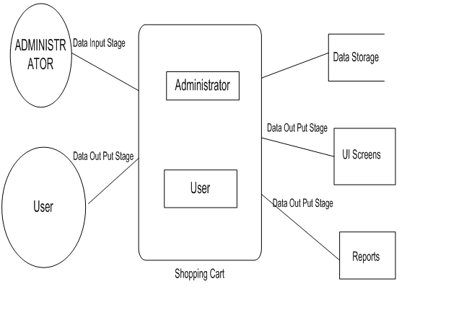  
fig 4.1

HRMS

**LoginActivity.java:-**

public class Login extends AppCompatActivity {

ActivityLoginBinding activityLoginBinding;

FirebaseDatabase firebaseDatabase;

DatabaseReference databaseReference, databaseReference_google;

SharedPreferences sharedPreferences;

// MyCustomAdapter customAdapter;

MyPojo myPojo, myPojo_google;

ProgressDialog dialog, dialog_integration;

//initialising GoogleSignInOption and GoogleSignInClient

GoogleSignInClient googleSignInClient;

GoogleSignInOptions googleSignInOptions;

String userMobile;

//firebase Auth

FirebaseAuth firebaseAuth;

FirebaseUser user;

String userName;

String mobilePattern, passwordPattern;

@Override

protected void onCreate(Bundle savedInstanceState) {

super.onCreate(savedInstanceState);

setContentView(R.layout.activity_login);

activityLoginBinding = DataBindingUtil.setContentView(this, R.layout.activity_login);

mobilePattern = mobilePattern = "^([0-9]{10,10})$";

passwordPattern = "^([a-zA-Z0-9@#$%^&+=]{6,15})$";

//getting userName from register activity

/* Intent user=getIntent();

userName=user.getStringExtra("username");

Log.d("12345", "login: "+userName);*/

firebaseAuth = FirebaseAuth.getInstance();

firebaseDatabase = FirebaseDatabase.getInstance();

// databaseReference = firebaseDatabase.getReference("Details").child("accounts");

databaseReference = firebaseDatabase.getReference("data").child("users");

dialog = new ProgressDialog(this);

dialog.setTitle("please wait....");

dialog.setMessage("verifying user");

dialog.setCanceledOnTouchOutside(false);

//integration dialog

dialog_integration = new ProgressDialog(this);

dialog_integration.setTitle("please wait....");

dialog_integration.setMessage("verifying account");

dialog_integration.setCanceledOnTouchOutside(false);

sharedPreferences = getSharedPreferences("save", 0);

if (sharedPreferences.getBoolean("status", false)) {

Intent intent = new Intent(Login.this, HomePage.class);

startActivity(intent);

finish();

}

activityLoginBinding.Register.setOnClickListener(new View.OnClickListener() {

@Override

public void onClick(View view) {

Intent intent = new Intent(Login.this, Register.class);

startActivity(intent);

}

});

activityLoginBinding.login.setOnClickListener(new View.OnClickListener() {

@Override

public void onClick(View view) {

if (TextUtils.isEmpty(activityLoginBinding.Mobile.getText().toString()) && TextUtils.isEmpty(activityLoginBinding.editTextPassword.getText().toString())) {

Toast.makeText(Login.this, "both the fields are mandatory", Toast.LENGTH_SHORT).show();

activityLoginBinding.Mobile.setError(null);

} else if (TextUtils.isEmpty(activityLoginBinding.Mobile.getText().toString())) {

activityLoginBinding.Mobile.setError("please enter mobile number");

} else if (TextUtils.isEmpty(activityLoginBinding.editTextPassword.getText().toString())) {

activityLoginBinding.editTextPassword.setError("please enter a password");

} else if (!activityLoginBinding.Mobile.getText().toString().matches(mobilePattern)) {

activityLoginBinding.Mobile.setError("mobile must be of 10 digits");

} else if (!activityLoginBinding.editTextPassword.getText().toString().matches(passwordPattern)) {

activityLoginBinding.editTextPassword.setError("length range between 6-15");

} else {

activityLoginBinding.editTextPassword.setError(null);

activityLoginBinding.Mobile.setError(null);

dialog.show();

databaseReference.addValueEventListener(new ValueEventListener() {

@Override

public void onDataChange(DataSnapshot dataSnapshot) {

boolean userFound = false;

for (DataSnapshot data : dataSnapshot.getChildren()) {

myPojo = data.getValue(MyPojo.class);

if (activityLoginBinding.Mobile.getText().toString().equals(myPojo.getMobile())

&& activityLoginBinding.editTextPassword.getText().toString().equals(myPojo.getPassword())) {

dialog.cancel();

userFound = true;

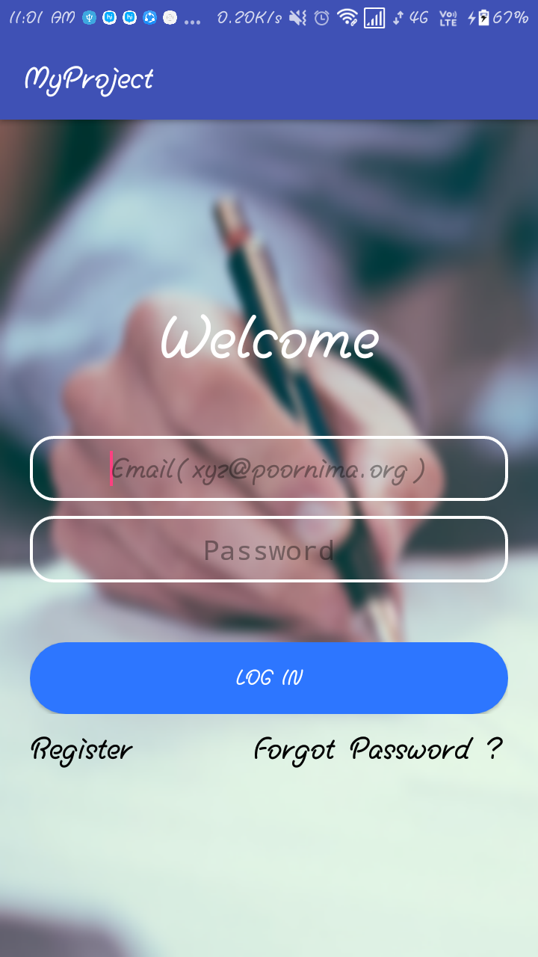 fig 4.2 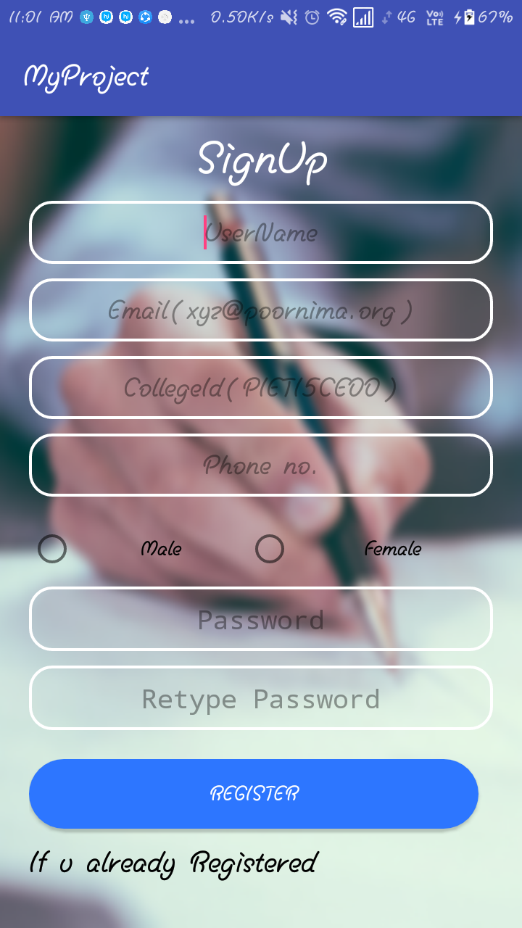fig 4.3

1. Sprint Backlog-2

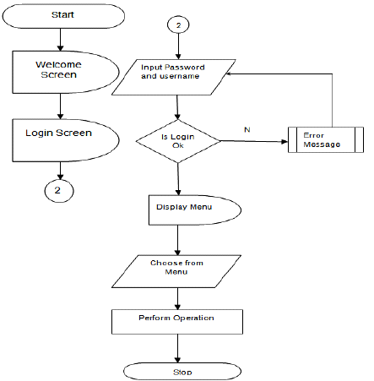  
fig 4.4

The main agenda of sprint backlog 2 is to create the required information set in each profile created after registration. Various features like to add notice or any application will be performed here, apart from this an employee can have its own information like fee status, bounce information, leaves, transport information etc.

**RegisterationActivity.java –**

package com.cdac.vinod.mygrocerystore.Activities;

import android.app.DatePickerDialog;

import android.app.ProgressDialog;

import android.content.Intent;

import android.content.SharedPreferences;

import android.databinding.DataBindingUtil;

import android.net.Uri;

import android.os.Bundle;

import android.support.annotation.NonNull;

import android.support.design.widget.Snackbar;

import android.support.v7.app.AppCompatActivity;

import android.text.TextUtils;

import android.util.Log;

import android.util.TypedValue;

import android.view.View;

import android.widget.DatePicker;

import android.widget.TextView;

import android.widget.Toast;

import com.cdac.vinod.mygrocerystore.HelperClass.SelectImageHelper;

import com.cdac.vinod.mygrocerystore.POJO_Class.MyPojo;

import com.cdac.vinod.mygrocerystore.R;

import com.cdac.vinod.mygrocerystore.databinding.ActivityRegisterBinding;

import com.google.android.gms.tasks.OnFailureListener;

import com.google.android.gms.tasks.OnSuccessListener;

import com.google.firebase.database.DatabaseReference;

import com.google.firebase.database.FirebaseDatabase;

import com.google.firebase.storage.FirebaseStorage;

import com.google.firebase.storage.StorageReference;

import com.google.firebase.storage.UploadTask;

import java.util.Calendar;

import java.util.Objects;

import java.util.Random;

public class Register extends AppCompatActivity {

ActivityRegisterBinding activityRegisterBinding;

ProgressDialog dialog;

SelectImageHelper helper;

FirebaseDatabase firebaseDatabase;

DatabaseReference databaseReference;

StorageReference storageReference;

Random random;

MyPojo myPojo;

String emailPattern, namePattern, mobilePattern, passwordPattern;

@Override

protected void onCreate(Bundle savedInstanceState) {

super.onCreate(savedInstanceState);

setContentView(R.layout.activity_register);

emailPattern = "^([_A-Za-z0-9-.]+)*@[A-Za-z0-9]+(\\.[A-Za-z0-9]+)*(\\.[A-Za-z]{2,4})$";

namePattern = "^([a-zA-Z]{2,15})$";

mobilePattern = "^([0-9]{10,10})$";

// passwordPattern = "^(?=.*[0-9])(?=.*[a-z])(?=.*[A-Z])(?=.*[@#$%^&+=])(?=\\S+$).{6,}$";

passwordPattern="^([a-zA-Z0-9@#$%^&+=]{6,15})$";

activityRegisterBinding = DataBindingUtil.setContentView(this, R.layout.activity_register);

//get FirebaseDatabase Instance

firebaseDatabase = FirebaseDatabase.getInstance();

//get selectHelper class instance

helper = new SelectImageHelper(this, activityRegisterBinding.circular);

//get StorageReference Instance

storageReference = FirebaseStorage.getInstance().getReference();

//dialog

dialog = new ProgressDialog(this);

dialog.setTitle("please wait.....");

dialog.setMessage("registering data to Database");

dialog.setCanceledOnTouchOutside(false);

random = new Random();

final String s1 = String.valueOf(random.nextInt(263443));

activityRegisterBinding.circular.setOnClickListener(new View.OnClickListener() {

@Override

public void onClick(View view) {

//using SelectImageHelper class to browse image

helper.selectImageOption();

}

});

//making edittext cli

activityRegisterBinding.editTextDOB.setFocusable(false);

activityRegisterBinding.editTextDOB.setClickable(true);

activityRegisterBinding.editTextDOB.setOnClickListener(new View.OnClickListener() {

@Override

public void onClick(View view) {

final Calendar cal = Calendar.getInstance();

int day = cal.get(Calendar.DAY_OF_MONTH);

int month = cal.get(Calendar.MONTH);

int year = cal.get(Calendar.YEAR);

DatePickerDialog datePickerDialog = new DatePickerDialog(Register.this, android.R.style.Theme_DeviceDefault_Dialog_Alert, new DatePickerDialog.OnDateSetListener() {

@Override

public void onDateSet(DatePicker datePicker, int year, int month, int day) {

activityRegisterBinding.editTextDOB.setText(day + "/" + (month + 1) + "/" + year);

}

}, year, month, day);

datePickerDialog.show();

}

});

**CHAPTER 5**

**CONCLUSION**

( 3 to 5 page)

**Results:**

The main objective to build an automated and computerized system which will work in order to give proper detail of any employee to the administration and all required information and notification to the every employee.

It will reduce human effort and will work to maintain the proper management of employee related information like bounce attendance, leave application, fee status etc.

**Conclusion:**

Finally the main problem is solved here that as every employee has its own data which has to be maintain by the company. This process required human effort to a great extent. To reduce this human effort it is required to develop an automated and computerized system which maintain record of these information.

**Future Scope:**

Nothing is perfect in this world. So, we are also no exception. Although, we have tried our best to present the information effectively, yet, there can be further enhancement in the Application. We have taken care of all the critical aspects, which need to take care of during the development of the Project. Like the things this project also has some limitations and can further be enhances by some one, because there are certain drawbacks that do not permit the system to be 100% accurate..

**ANNEXURES**

References

(1) [www.w3Schools.com](http://www.w3Schools.com)

(2) [www.javatpoint.com](http://www.javatpoint.com)

(3) Material Design

(4) Android Studio

(5) [www.android.google.com](http://www.android.google.com)